Greetings from Millington,

A quick overview/agenda for the October OP Drumbeat will cover Career Counselor updates, Record / Board Training, Q&A, and Closing Remarks.

CAPT Risley: Opening Remarks:

Good morning and welcome to the October OP Drumbeat TEAMS series. This month we will be talking about records maintenance and all things board related. Our guest speakers are CAPT Dave Carroll and CDR Travis Miller. CAPT Carroll was a CDR milestone board member this year and CDR Miller, a former detailer, has excellent records maintenance experience. Thank you both for providing training on this important topic. Now I’ll turn it over to the Career Counselor for updates.

LCDR Mays: Career Counselor Updates:

1. Reminder to the community about this year’s All Calls. The Early Bird Special on tickets will end Oct 31st. For complete details please see the October OP Drumbeat.

I’ll turn it over to CDR Miller for record / board training.

Guest Speakers: CAPT Dave Carroll, CDR Travis Miller, and CDR Dustin “Wink” Martindale

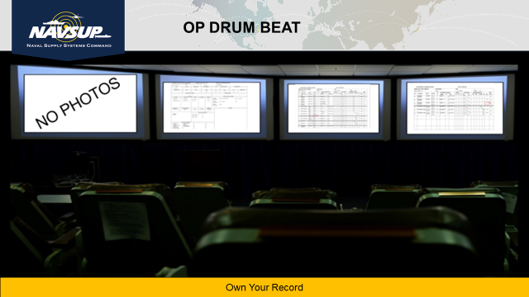

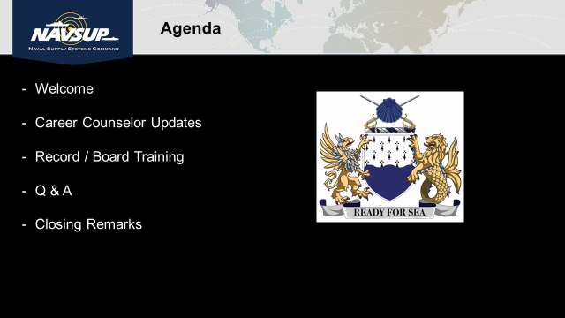

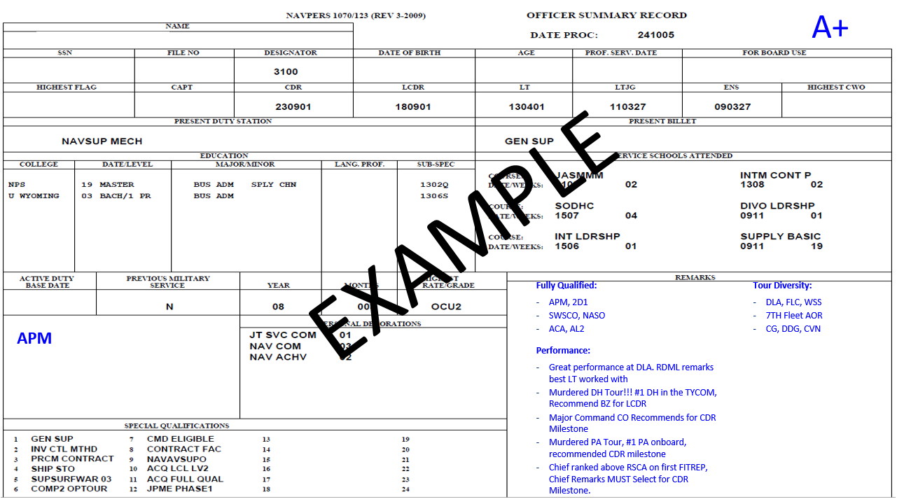

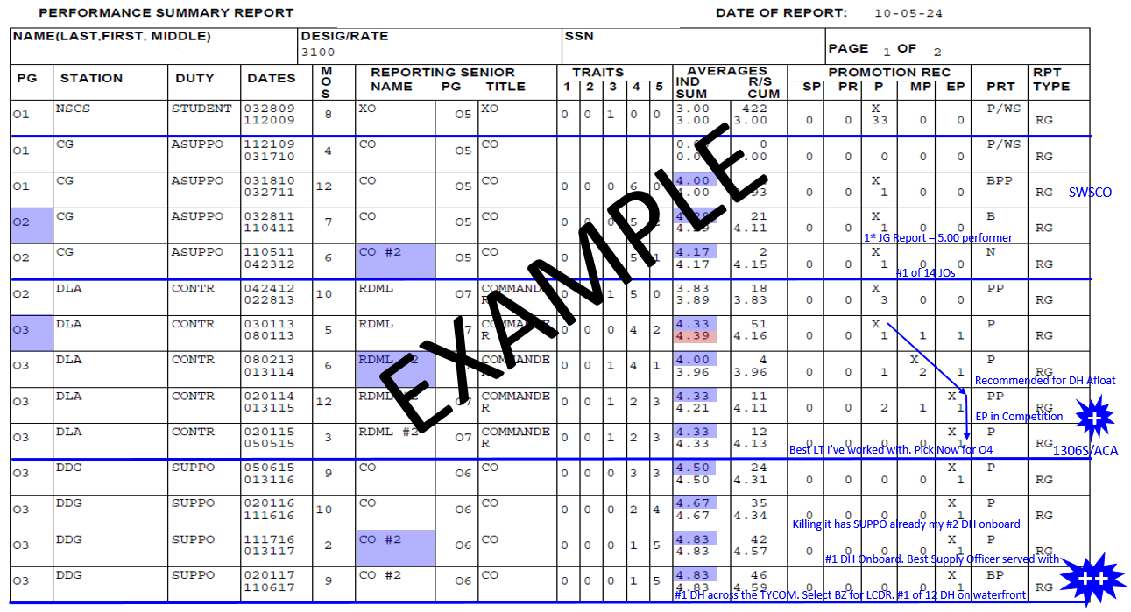

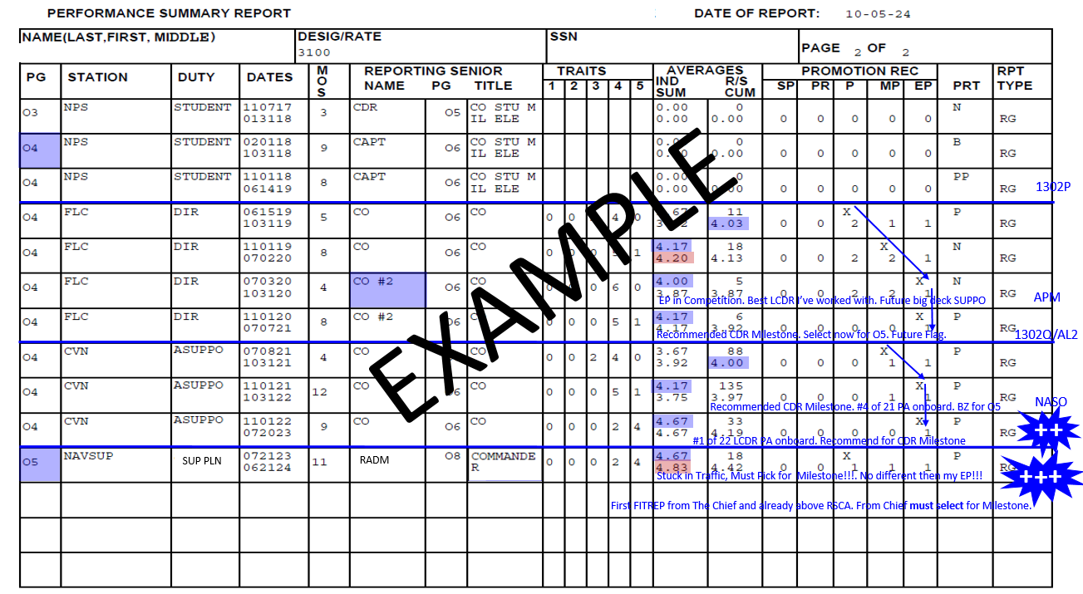

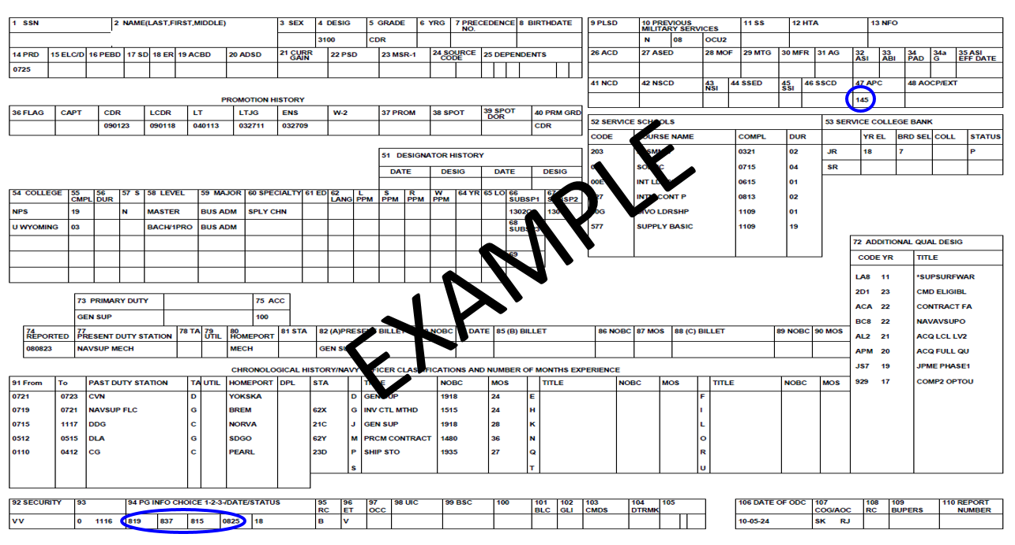

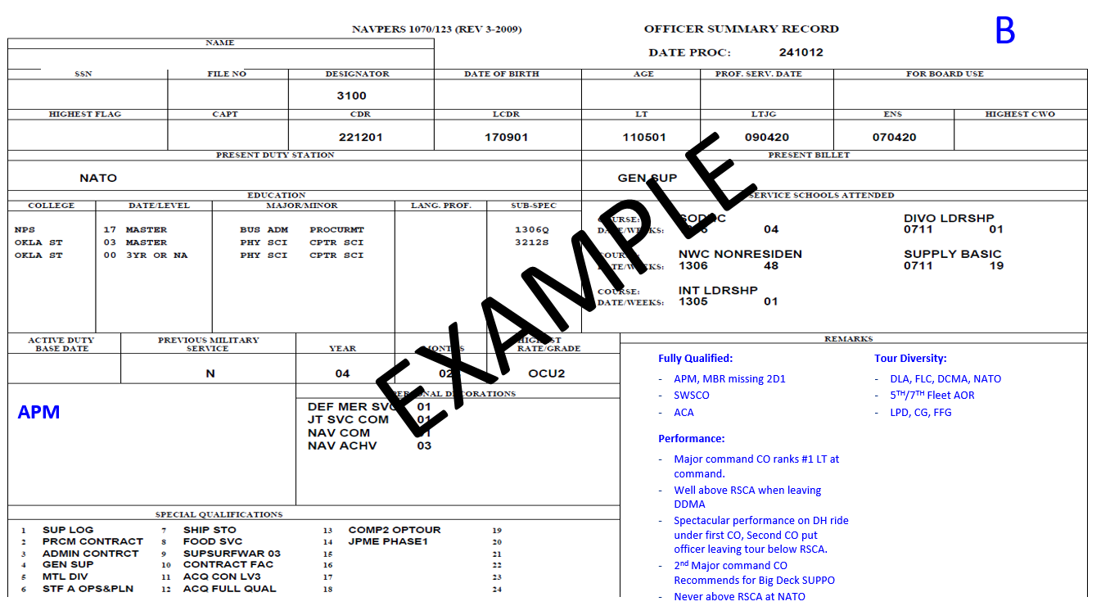

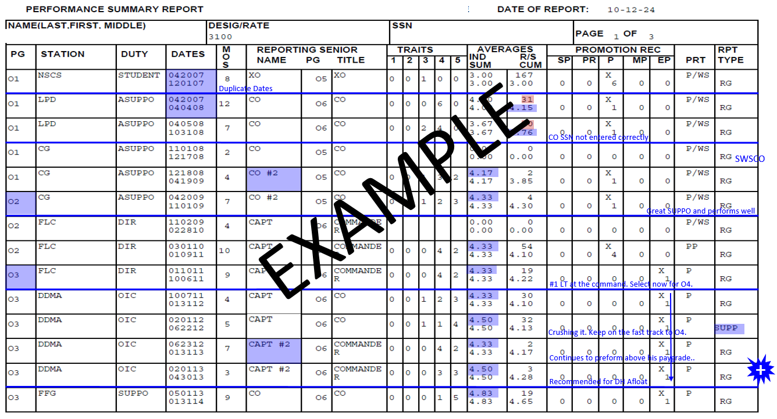

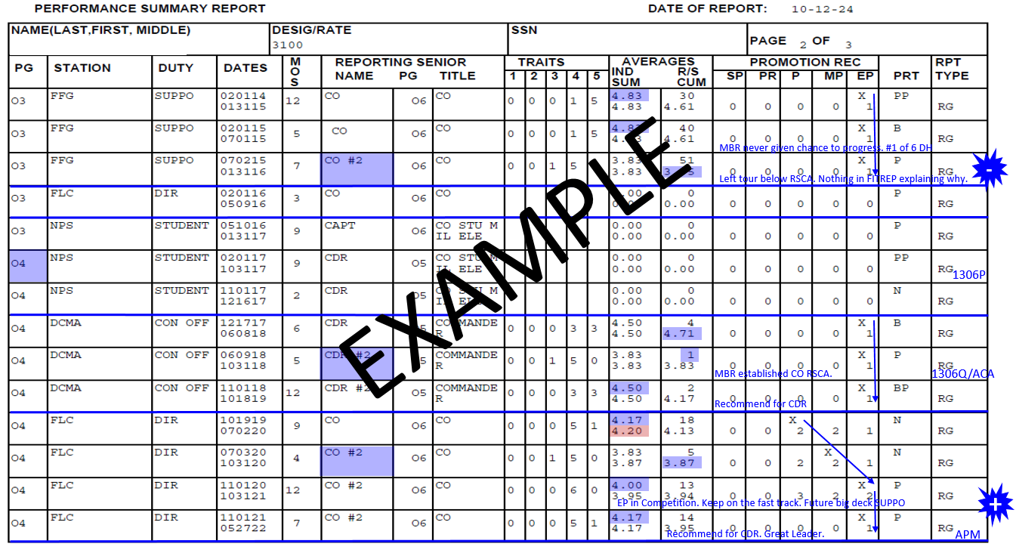

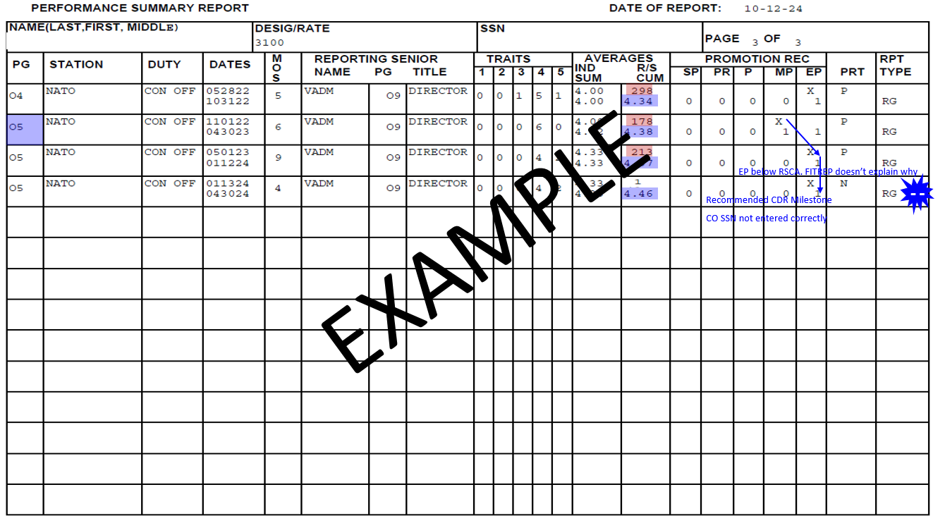

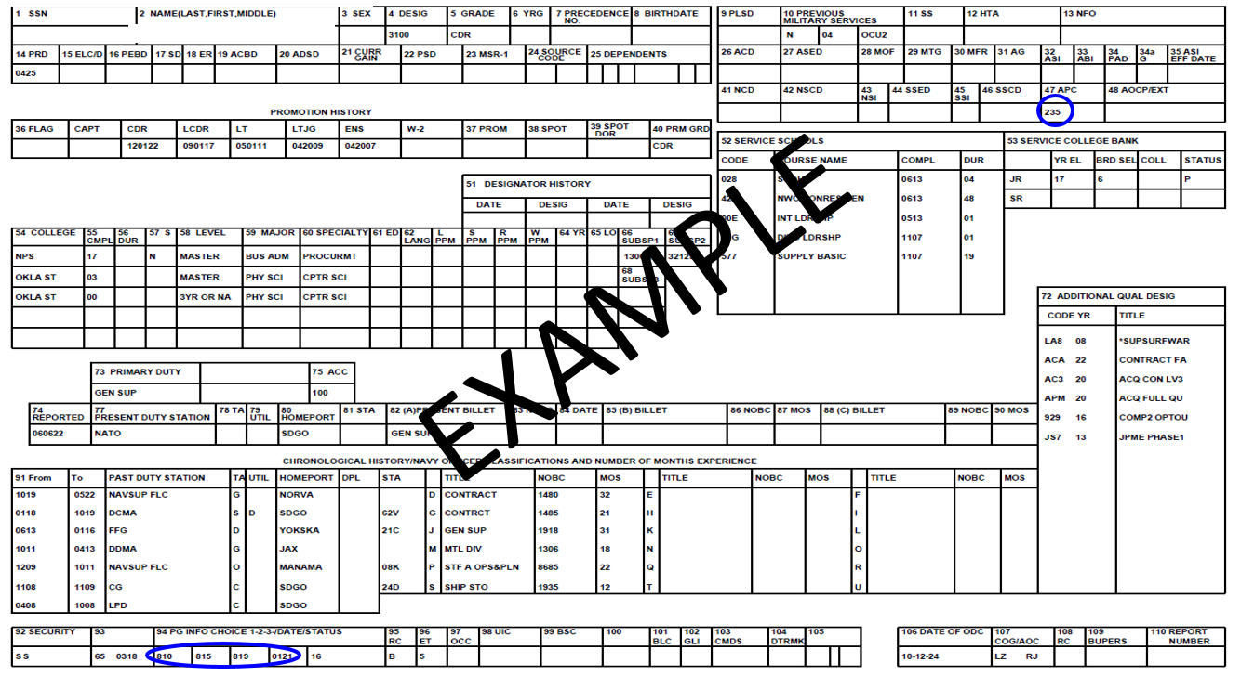



Record Review Process:

To find detailed information on how to review a record, please visit the “Its Your Record” Playbook link found on the Supply Corps Career Counselor Webpage.

[It's Your Career Playbooks](https://www.mynavyhr.navy.mil/Career-Management/Detailing/Officer/Pers-44-Staff-RL/Supply-Corps-Officer/Career-Playbooks/)

_____________________________________________________________________________________

CAPT Carroll Remarks:

Everyone should be familiar with the process of a records review and for any O3 and above you should be very familiar with the process. Your CO and fellow JOs you’re leading are going to come to you for advice and you need to have the expertise to walk them through how a Supply Officer gets promoted.

The O4 ASUPPO/PA tour is a great thing to have in your record. Our community values the O4 Op tour and, in this case, the officer did an O4 ASUPPO tour (*referring to the slides*). If you are selected for Milestone what’s better than detailing an O5 back to a carrier that already has paperwork from a carrier CO talking about how the officer is ready to be a milestone SUPPO.

Lastly, for O4s coming out of NPS, your career is not over if your first FITREP onboard is a “P” and you’re below RSCA. The board expects to see you progress from the “P” to “MP” to “EP” and from below to above RSCA. The board has ~60-90 seconds to brief your record, so work with multiple mentors to review your record and ensure your record tells the full and best story in those 60-90 seconds.

Definitions:

Ringing the Bell – Getting the EP before leaving your tour. Prefer you get it while in competition, not just when you are departing.

Air Gap – Reporting senior has the ability to give you the EP, but gives you an MP or P instead.

_____________________________________________________________________________________

Q & A Session:

Q1. CAPT Whittle: The 2 most common concerns I get while mentoring JOs is they don’t have a record where they are consistently above RSCA and don’t understand why this isn’t always a bad thing. The other concern is their station or duty aren’t the same/consistent on the PSR. Can you discuss further on these 2 topics?

A1. CAPT Carroll: It’s actually very common for officers to start out below RSCA and is quite commonly the norm. The biggest thing mentors should look for is that the officer is progressing The Supply Corps wants to see you progress to the EP and it’s even better if you do it in competition. Overall we want to see sustained superior performance first. Regarding the second question these issues are usually corrected before the board members get into the tank. These issues typically don’t’ come up during the record brief for boards.

Q2. LCDR Gumarang: Is there a reason why we have to show officer’s names and age during board reviews?

A2. CAPT Risley: There has been some conversation about removing names and gender at NPC, but we aren’t to the point of having a final decision on this topic yet. For boards, they are usually only allowed to talk positive things about the officer, but if it’s negative and not in the record it can’t be mentioned.

A2. CAPT Barich: You’re questioning the integrity of the board. While names and age are part of the officer’s record, none of those items are mentioned due to integrity and professionalism of the board. The board process is very fair and the record brief is based off the officer’s experience and competition throughout their career.

A2. CAPT Carroll: The individual’s record speaks for itself and it’s the record that gets the officer promoted. Name and age don’t come up. The officer’s performance is what’s discussed. The board members also challenge each other during the brief if they don’t see what the briefer is seeing in the record.

A2. CAPT Jenkins: With how quickly the briefs go for each record I didn’t feel like I had the time to brief name and age. We spent the whole time briefing the officer’s performance and the whole story for the officer. There’s also a bias brief beforehand to help identify and eliminate bias from the board.

Q3. LCDR Morlan: With the constant discussion with JOs about transparency of the board, would there ever be a possibility of releasing the marked up PSR/OSR to the community?

A3. CAPT Risley: Record mark ups from the board are privy to the board, so no. Also any LOR, LTB, or awards submitted directly to the board via board correspondence are discarded after the board is over. Board members are also not able to provide a records review after the board and results have been released. They can discuss general themes, but have to be careful not to divulge board matters.